Design - Use Cases

A report describing the Use Cases for the Network Appliance Service Utilisation Framework

Version: 1.0

By

Paul Fergus

Supervised by

Dr. Martin Hanneghan and Prof. Madjid Merabti

Networked Appliances Lab
School of Computing and Mathematical Sciences
Liverpool John Moores University

Table of Contents
Table of Contents ii
Table of Figures viii
1 Use Case: Start Device 1
1.1 Description 1
1.2 Issues 1
1.3 Requirements 1
1.4 Actors/Roles 2
1.5 Goals/Context 2
1.6 Assumptions 3
1.7 Scenario/Steps 3
1.8 Extensions 3
2 Use Case: Connect Device to the Network 4
2.1 Description 4
2.2 Issues 4
2.3 Requirements 4
2.4 Actors/Roles 4
2.5 Goals/Context 5
2.6 Assumptions 5
2.7 Scenario/Steps 5
2.8 Extensions 5
3 Use Case: Create Device Capability Advertisement 6
3.1 Description 6
3.2 Issues 6
3.3 Requirements 6
3.4 Actors/Roles 7
3.5 Goals/Context 7
3.6 Assumptions 7
3.7 Scenario/Steps 7
3.8 Extensions 8
4 Use Case: Publish Device Capability Advertisement 9
4.1 Description 9
4.2 Issues 9
4.3 Requirements 9
4.4 Actors/Roles 9
4.5 Goals/Context 10
4.6 Assumptions 10
4.7 Scenario/Steps 10
4.8 Extensions 10
5 Use Case: Publish Implementation Services 11
5.1 Description 11
5.2 Issues 11
5.3 Requirements 11
5.4 Actors/Roles 11
5.5 Goals/Context 11
5.6 Assumptions 12
5.7 Scenario/Steps 12
5.8 Extensions 12
6 Use Case: Create Peer Service Advertisements 13
6.1 Description 13
6.2 Issues 13
6.3 Requirements 13
6.4 Actors/Roles 14
6.5 Goals/Context 14
6.6 Assumptions 15
6.7 Scenario/Steps 15
6.8 Extensions 15
7 Use Case: Publish Peer Service 16
7.1 Description 16
7.2 Issues 16
7.3 Requirements 16
7.4 Actors/Roles 16
7.5 Goals/Context 16
7.6 Assumptions 17
7.7 Scenario/Steps 17
7.8 Extensions 17
8 Use Case: Create Semantic Service Models 18
8.1 Description 18
8.2 Issues 18
8.3 Requirements 18
8.4 Actors/Roles 19
8.5 Goals/Context 19
8.6 Assumptions 19
8.7 Scenario/Steps 19
8.8 Extensions 20
9 Use Case: Find Core Services 21
9.1 Description 21
9.2 Issues 21
9.3 Requirements 21
9.4 Actors/Roles 21
9.5 Goals/Context 22
9.6 Assumptions 22
9.7 Scenario/Steps 22
9.8 Extensions 23
10 Use Case: Retrieve Context Templates 24
10.1 Description 24
10.2 Issues 24
10.3 Requirements 24
10.4 Actors/Roles 24
10.5 Goals/Context 25
10.6 Assumptions 25
10.7 Scenario/Steps 25
10.8 Extensions 25
11 Use Case: Realise Context Templates 26
11.1 Description 26
11.2 Issues 26
11.3 Requirements 26
11.4 Actors/Roles 26
11.5 Goals/Context 27
11.6 Assumptions 27
11.7 Scenario/Steps 27
11.8 Extensions 28
12 Use Case: Discover Peer Service 29
12.1 Description 29
12.2 Issues 29
12.3 Requirements 29
12.4 Actors/Roles 29
12.5 Goals/Context 29
12.6 Assumptions 30
12.7 Scenario/Steps 30
12.8 Extensions 30
13 Use Case: Invoke Peer Service 31
13.1 Description 31
13.2 Issues 31
13.3 Requirements 31
13.4 Actors/Roles 32
13.5 Goals/Context 32
13.6 Assumptions 32
13.7 Scenario/Steps 32
13.8 Extensions 33
14 Use Case: Process Service Request 34
14.1 Description 34
14.2 Issues 34
14.3 Requirements 34
14.4 Actors/Roles 35
14.5 Goals/Context 35
14.6 Assumptions 36
14.7 Scenario/Steps 36
14.8 Extensions 36
15 Use Case: Perform Semantic Interoperability 37
15.1 Description 37
15.2 Issues 37
15.3 Requirements 37
15.4 Actors/Roles 37
15.5 Goals/Context 38
15.6 Assumptions 38
15.7 Scenario/Steps 38
15.8 Extensions 39
16 Use Case: Perform Abstract Match 40
16.1 Description 40
16.2 Issues 40
16.3 Requirements 40
16.4 Actors/Roles 40
16.5 Goals/Context 41
16.6 Assumptions 41
16.7 Scenario/Steps 41
16.8 Extensions 41
17 Use Case: Perform Concrete Match 42
17.1 Description 42
17.2 Issues 42
17.3 Requirements 42
17.4 Actors/Roles 43
17.5 Goals/Context 43
17.6 Assumptions 44
17.7 Scenario/Steps 44
17.8 Extensions 44
18 Use Case: Build Signature 45
18.1 Description 45
18.2 Issues 45
18.3 Requirements 45
18.4 Actors/Roles 46
18.5 Goals/Context 46
18.6 Assumptions 46
18.7 Scenario/Steps 46
18.8 Extensions 47
19 Use Case: Find Intermediary Service 48
19.1 Description 48
19.2 Issues 48
19.3 Requirements 48
19.4 Actors/Roles 49
19.5 Goals/Context 49
19.6 Assumptions 49
19.7 Scenario/Steps 49
19.8 Extensions 50
20 Use Case: Encrypt and Decrypt Data 51
20.1 Description 51
20.2 Issues 51
20.3 Requirements 51
20.4 Actors/Roles 51
20.5 Goals/Context 51
20.6 Assumptions 52
20.7 Scenario/Steps 52
20.8 Extensions 52
21 References 53

Table of Figures
Figure 1 Start Device 1
Figure 2 Connect Device to the Network 4
Figure 3 Create Device Capability Advertisement 6
Figure 4 Publish Device Capability Advertisement 9
Figure 5 Publish Implementation Services 11
Figure 6 Create Peer Service Advertisements 13
Figure 7 Publish Peer Service 16
Figure 8 Create Semantic Service models 18
Figure 9 Find Core Services 21
Figure 10 Retrieve Context Templates 24
Figure 11 Realise Context Templates 26
Figure 12 Discover Peer Service 29
Figure 13 Invoke Peer Service 31
Figure 14 Process Service Request 34
Figure 15 Perform Semantic Interoperability 37
Figure 16 Perform Abstract Match 40
Figure 17 Perform Concrete Match 42
Figure 18 Build Signature 45
Figure 19 Find Intermediary Service 48
Figure 20 Encrypt and Decrypt Data 51

Use Case: Start Device

Description
This Use Case illustrates a typical scenario when a Device is initially switched on within this framework. The Use Case diagram is illustrated in Figure 1.
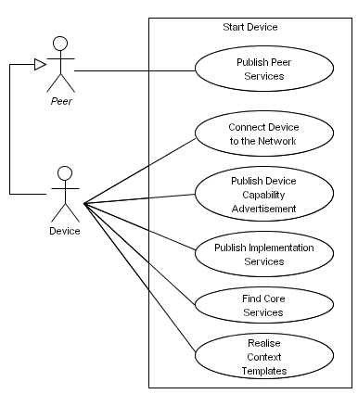
Figure 1 Start Device

Issues
The issues associated with the Use Case are not known at this stage.

Requirements
A device must connect to the network and publish the peer services it provides including any corresponding implementation services. Devices that join the network will vary in the capabilities they support, therefore every device must publish the capabilities it supports in terms of the hardware, software, and networking capabilities it has. Each device must use several core services that allow it to semantically discover services, perform semantic interoperability and dynamically compose services into desired configurations. The device may implement zero or more of these core services – if a device does not explicitly implement a core service then the service must be discovered within the P2P network and bound to before the device can be successfully integrated within the environment. Devices will have a number of application specific services that expose the functions the device offers, which may be used in isolation or as part of a larger composition. In this instance devices will provide Context Templates which describe how application specific services can be used within these larger compositions. Context Templates are semantic descriptions, which contain a number of semantic hooks that describe the required services needed in a particular context. Semantic hooks can be thought of as semantic service requests that describe the type of service required. All the semantic hooks within the Context Template must be resolved before the device can be used within that context. The Context Templates themselves can be dynamic and may exist within bigger ontological structures, which may be evolved over time.
Another very important requirement is that the Context Templates themselves must be generic enough so that they only describe the composite functionality required without explicitly referencing particular services. The Context Template is designed to describe the salient concepts that describe the global functionality a particular composition must provide. The concepts themselves provide a level of abstraction that describe “what” is required and do not concern themselves with the “how” part of the composition.

Actors/Roles
The actors within this Use Case are as follows:
- Device: The device is an actor within this Use Case. When a device is switched on it publishes its peer services and corresponding implementation services, which may be Web Services, RMI, CORBA or SOAP-RPC. The framework is not concerned with the implementation details regarding the service technology being used – this decision is left to the device manufacturer. The device must also publish its hardware, software and networking capabilities and it must find and bind to all the required core services, which may reside locally or remotely within the P2P network. It must also retrieve the Context Templates it supports and bind all the semantic hooks they contain by discovering the required services.
- Peer: The Peer is the P2P interface and is responsible for publishing peer services and all P2P communications.

Goals/Context
Within this Use Case there are a number of goals that need to be addressed depending on the particular actor involved.
- The device must be connected to the network using secure authentication, all data sent and received within the network must be encrypted and decrypted and all services used that reside outside the device must be authenticated – how the security model is implemented is dependent on the device manufacturer’s security policy.
- Find Core Services: The framework consists of several core services, which must be discovered locally or remotely within the P2P network and bound to. Only when all the core service bindings are present can the device successfully integrate itself within the network. Devices are not required to explicitly implement these services if they have limited capabilities. In this instance they can outsource this functionality to remote services.
- Publish the Devices Capabilities: All devices need to integrate themselves within the environment and publish the capabilities they support. This will include processing capabilities, memory constraints, display capabilities, the network protocol being used, bandwidth capabilities and any software installed on the device – there may be several other important features that need to be described within the device capability advertisement.
- Publish Implementation Services: When a device is initially switched on it must ensure that all the implementation services it uses are successfully published. The type of implementation services used is decided by the device manufacturer however they must implement the generic interfaces provided by the framework.
- Publish Peer Services: Peer service advertisements must be published locally and remotely within the P2P network. Although it is possible to place the service logic within a Peer Service, it is advised that each Peer Service be mapped onto a corresponding implementation service to maintain the abstraction properties supported by the framework and to ensure easy maintainability – this allows multiple service technologies to be seamlessly integrated, used and changed over time.
- Realise Context Templates: When a device is initially switched on it must retrieve and process each Context Template the device uses and map all the semantic hooks each template contains with corresponding semantic services either provided by the device itself or remotely by other devices within the P2P network.

Assumptions
The assumption within this Use Case is that Public Key infrastructures and Digital Certificates are used for authentication and data encryption and decryption. The framework provides generic interfaces that allow any security model to be overridden and implemented by device manufacturers.

Scenario/Steps
When the Device is initially switched on it first connects to the network. It connects using username and password authentication. If creates it security model, which may be based on Public Key Infrastructures, which may also include Digital Signatures – the security model used is decided by the device manufacturer. Once the device has successfully authenticated itself and connected itself to the network all the core services are discovered and bound to. These services may be provided by the device itself or remotely by other devices that choose to share these services within the P2P network. Once this process is complete the device creates a Device Capability Advertisement and publishes it locally and remotely within the P2P network. This advertisement details the hardware, software and networking constraints the device supports, which allows other devices to select services based on the capabilities the device supports.
The device publishes each of the Peer Services the device supports including the corresponding implementation services it uses. Once the peer and implementation services have been successfully published the device loads the Context Templates the device supports and tries to resolve all the semantic hooks by discovering and matching services that satisfy the semantic hook requirements. When all the semantic hooks within the Context Template have been resolved, the context template is ready to use.

Extensions
Provisions need to be made that describes how the Context Templates are managed. It is highly likely that services will unexpectedly become unavailable for a variety of reasons, the most obvious being the device disconnects from the P2P network, taking all the services it provides with it.

Use Case: Connect Device to the Network

Description
This Use Case illustrates how a device is connected to the network within this framework. The Use Case diagram is illustrated in Figure 2.
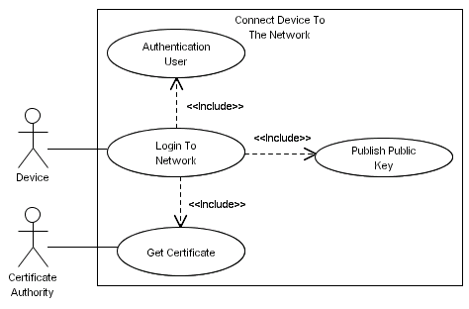
Figure 2 Connect Device to the Network

Issues
The issues associated with the Use Case are not known at this stage.

Requirements
Within this framework security is paramount. Devices will come and go and will not be controlled by any centralised third party organisation. Mechanisms need to be implemented that authenticate devices when they connect to the network and allow data to be encrypted and decrypted before data is transferred between devices. Consequently devices must connect to the network and provide a username and password – typically there will not be a user interface for simple devices therefore this process must be securely automated. Once devices have successfully authenticated themselves and connected to the network they are required to sign the public key they will use to encrypt and decrypt data using a digital certificate. Once the public key has been signed it must be published within the P2P network. This means that the device must retrieve a previously obtained certificate from the devices persistent storage or from some certificate authority.

Actors/Roles
The actors within this Use Case are as follows:
- Device: When the device is switched on it will automatically connect to the network and authenticate itself using a username and password. This process will include obtaining a certificate and publishing a public key to decrypt the data the device encrypts.
- Certificate Authority: The framework does not place any constraints on the certificate authority, which may be the device itself of some recognised third party certification authority.

Goals/Context
Within this Use Case there are a number of goals that need to be addressed depending on the particular actor involved.
- Authenticate User: Mechanisms need to be developed that allow the device to securely store and retrieve the username and password required to logon to the network. No assumptions can be made as to whether a device will have a user interface therefore the process of connecting and authenticating the device must be securely automated.
- Get Certificate: Certificates need to be stored and retrieved from the persistent storage provided by the device or from some third party certification authority. Certificates must be used to sign encrypted data before it is propagated within the P2P network.
- Publish Public Key: Public key infrastructures must be implemented and once the public key has been signed and published within the network, all data sent and received must be encrypted and decrypted using the Private/Public Key infrastructure.

Assumptions
The assumption within this Use Case is that Public Key infrastructures and Digital Certificates are used for authentication and data encryption and decryption. However the framework provides generic interfaces that allow any security model to be overridden and implemented by device manufacturers.

Scenario/Steps
When the device is initially switched on it will retrieve the secure authentication details from the devices persistent storage and connect itself to the P2P network. If the device successfully connects to the network it checks to see if it has a valid certificate. If it does not it requests the certificate from the certification authority – this process is repeated for the public key. Once the key is retrieved it is digitally signed using the certificate and published within the P2P network. All data sent and received from the P2P network will be encrypted and decrypted using the private and public keys.

Extensions
Further analysis is required for the security within this framework to ensure that it provides the most secure mechanisms without impeding on the overall performance of the system. This is important because security may require significant computational processing, which some devices may not have the capabilities to perform. Consequently device capabilities need to be taken into account and security mechanisms adapted accordingly. Furthermore, due to the limitations associated with PKI we may need to consider trust within the P2P network and determine whether certification authorities and public key infrastructures are effective enough.

Use Case: Create Device Capability Advertisement

Description
This Use Case illustrates how the capabilities of the device are described in terms of the devices hardware, software and networking capabilities within this framework. The Use Case diagram is illustrated in Figure 3.
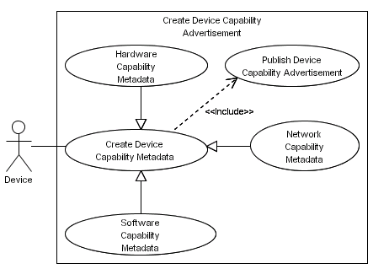
Figure 3 Create Device Capability Advertisement

Issues
The issues associated with the Use Case are not known at this stage.

Requirements
Devices within ad hoc network environments will differ in the capabilities they have and we envisage that devices ranging from microcontrollers to personal computers will be interconnected. This brings with it additional challenges when discovering and using the services such devices provide. Before a device commits to using a service provided by another device it will first determine if the device supports the required hardware, software and networking capabilities.
Devices that join the network will inherently have different hardware capabilities. For example a TV will be better equipped to process video and audio streams than a 3G Mobile Phone or a PDA. The hardware capabilities of devices need to be explicitly described so that other devices and services within the P2P network can determine whether the device is sufficiently equipped to be included in a composition. In this instance the device must advertise its memory capabilities, the processing power it has, and its screen size for example. Devices must describe a number of core features dependent on the type of device, however this is extensible and the features that are deemed important will be left to the device manufacturer to add.
Devices will also have different software capabilities. For example some devices may support several different virtual machines that offer services in a number of different languages such as Java and .NET. Furthermore the types of media formats supported by a device will differ. For example one particular DVD player may only be capable of processing DVD movie formats, whilst another DVD player may further support VCD, SVCD and DivX formats. More capable devices may also provide transcoding and adaptation services that will compress and convert media formats based on specific requirements. Consequently devices that join the network must also describe the software capabilities they have.
Devices will use different communication protocols, and furthermore they will have different bandwidth capabilities. Depending on the service high bandwidth capabilities may be required in order to maintain a high quality of service, such as high quality video streaming. Again as with hardware and software capabilities the device must describe the networking capabilities it supports.
Each device within this framework must describe these capabilities and publish them within the P2P network using a Device Capability Advertisement. This advertisement will allow devices to first analyse the devices capabilities before it commits to using the services it provides.

Actors/Roles
The actors within this Use Case are as follows:
- Device: When the device is started it will analyse its capabilities and create a Device Capability Advertisement, which will be published locally and remotely within the P2P network. The device will reflect on the internal hardware, software and networking capabilities it supports, and create metadata descriptions to reflect this, which will be inserted into the Device Capability Advertisement.

Goals/Context
Within this Use Case there are a number of goals that need to be addressed depending on the particular actor involved.
- Create Device Capability Advertisement: The device must create the Device Capability Advertisement, which will contain the hardware, software and networking metadata.
- Create Hardware, Software and Networking Capability Metadata: The device must reflect on its internal hardware, software and networking capabilities and describe them as metadata. Once this metadata has been created it must be inserted into the Device Capability Advertisement. This framework does not place any constraints on what capability attributes are deemed important – the definition of this attributes are determined by the device manufacturer.

Assumptions
The assumption within this Use Case is that the device capability advertisement is described using RDF(S) [6] based metadata language. This could be a custom format, or based on an existing standard such as the W3C CC/PP [7] standard.

Scenario/Steps
When the device is initially switched on it creates a new blank Device Compatibility Advertisement, which is used to contain the hardware, software and networking metadata that describes the devices capabilities. The device determines the hardware capabilities it supports and describes them using metadata. Once the hardware descriptions have been collected by the device the metadata is inserted into the Device Capability Advertisement.
Once this insertion process is completed the device determines the software capabilities it supports and describes them as metadata. Once the required features have been extracted they inserted into the Device Capability Advertisement.
The last step requires the device to analyse the networking capabilities it has which includes the bandwidth it has and the network speed it supports. Again no constraints are placed on the features that are deemed important to effectively describe the networking capabilities. Once the networking features are extracted they are described as metadata and inserted into the Device Capability Advertisement.

Extensions
The Device Capability Advertisement may be used to discover and locate software packages implemented on a device such as codec’s for different media formats. Although this advertisement is not specifically designed for this purpose, it is possible within this framework to use the Device Capability Advertisement to first see what software is available before a software request is propagated within the P2P network.

Use Case: Publish Device Capability Advertisement

Description
This Use Case illustrates how a device publishes a capability advertisement locally and globally within the P2P network in this framework. The Use Case diagram is illustrated in Figure 4.
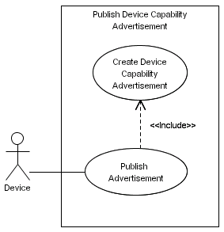
Figure 4 Publish Device Capability Advertisement

Issues
The issues associated with the Use Case are not known at this stage.

Requirements
Devices that join the network will have varied capabilities. For example a Notebook will be more capable of processing and displaying multimedia files than a mobile phone. Furthermore a TV may be more capable of displaying multimedia files than the Notebook screen. Therefore devices must describe their capabilities in terms of the hardware, software and networking features they support. This allows other devices within the network to process the devices capability advertisement and determine whether the device is capable enough before it decides to use the services it provides.
Within this framework the device must create this advertisement and publish it locally and remotely within the P2P network. Creating the advertisement itself is left to the device manufacturer, who may choice to create a new advertisement or use existing advertisements persisted on the device itself.

Actors/Roles
The actors within this Use Case are as follows:
- Device: The device within this Use Case advertises its capabilities by publishing descriptions within its local cache and remotely within the P2P network. The device begins by creating the advertisement, which may be hard coded within the framework logic or loaded from memory. Once the advertisement has been created it is then published.

Goals/Context
Within this Use Case there are a number of goals that need to be addressed depending on the particular actor involved.
- Create the Device Capability Advertisement: A device needs to publish the capabilities it has; consequentially the descriptions need to be described using an advertisement so that they can be discovered by other devices in the network.
- Publish the Device Capability Advertisement: When the device has created the Device Capability Advertisement it must be published locally in the devices cache and remotely within the P2P network.

Assumptions
Advertisements must be associated with other advertisements the device publishes using Globally Unique IDs (GUIDs). This framework does not place any constraints on how this is achieved; however each device and the advertisements it publishes must be globally unique. This may be achieved for example by using a combination of the MAC address and the device chip ID – how this is achieved is left to the device manufacturer.

Scenario/Steps
When the device is initially switched on it will publish its capabilities by creating a Device Capability Advertisement. There are no constraints on how this is achieved – the device manufacturer may create this within the application logic or load a file persisted on the device itself. Furthermore it is envisaged that device manufacturers will re-use new advertisements that reside in best practice repositories.
Once the device has created the advertisement it publishes it locally in the devices cache and remotely within the P2P network. Device manufacturers need to manage advertisements within the cache to ensure that older advertisements are removed and new advertisements persisted – this feature is left to the device manufacturer.
The Device Capability Advertisement will be associated with other advertisements published by the device using GUIDs. Consequently a GUID must be inserted into the advertisement that uniquely identifies the device. This is important because devices may not initially discover the Device Capability Advertisement but rather they will discover services. In this instance, before candidate services are selected, the GUID will be extracted from the service advertisement and used to discover the Device Capability Advertisement.

Extensions
All the advertisements a device publishes must be explicitly linked using GUIDs – this allows specific advertisements to be discovered using the GUID extracted for the current advertisement being processed.

Use Case: Publish Implementation Services

Description
This Use Case illustrates how implementation services are published within this framework. The Use Case diagram is illustrated in Figure 5.
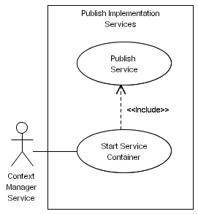
Figure 5 Publish Implementation Services

Issues
The issues associated with the Use Case are not known at this stage.

Requirements
When a device is initially started it must start the implementation services container and locally publish the implementation services hosted by the device. The device is free to ignore the ‘Start Service Container’ Use Case if the implementation services are published on some other remote device. For example the device may use a number of Web Services provided from within the organisation that are not solely for one particular devices use. These could be services that are used by internal applications, external customers or devices within the P2P network. Furthermore implementation services may not require implementation servers to register themselves, however mechanism must be provided to expose the implementation services so that they can be explicitly associated with peer services.

Actors/Roles
The actors within this Use Case are as follows:
- Device: The device within this Use Case starts the service container and provides the endpoint address whereby the services can be located – the creation of this address, in part, is dependent on the underlying communication protocol being used by the device, i.e. Bluetooth, Fire Wire or TCPIP.

Goals/Context
Within this Use Case there are a number of goals that need to be addressed depending on the particular actor involved.
- Get EndPoint Address: Depending on the underlying communication protocol being used, the device will partly construct this endpoint and pass it to the service container – in order to publish/discover services within the container this endpoint and some unique name for the service will be used. For example if the service implementation was based on the Web Services standard and the underlying communication protocol was IP-based then the device would provide the following endpoint “http://someIP:somePort/” and the service container would assign the names of each service it is publishing to the URL before it is published. For example the completed URL may look like “http://someIP:somePort/webservices/speaker/speaker001.wsdl”.
- Start Service Container: Before services can be published the container must be successfully started using the endpoint address.
- Publish Services: Each of the implementation services provided by the device must be published once the service container has been started.

Assumptions
The device manufacturer will decide what implementation services the device will use, if any, and ensure that the interfaces are maintained and supported by the peer services they bind to. The device manufacturer will decide how the endpoint address is constructed depending on the service technology being used and the underlying communication protocol the device uses.

Scenario/Steps
When the device is initially started it begins by starting the service container. The service container in turn uses the endpoint address provided by the device to publish the implementation services. This step is dependent on the underlying communication protocol and the service technology being used. This will result in an endpoint that specifies how a particular service can be found. For example one particular service endpoint could look something like this “http://someIP:somePort/webservices/speaker-services/speaker001.wsdl”. When the complete endpoints have been created the service container uses the implementation service along with the endpoints and publishes them within the container. The services themselves can be any type of service object (dependent on the service technology being used), and will be used to derive the service’s interface.

Extensions
How implementation services are implemented and published is dependent on the service technology being used and how this is achieved is left to the device manufacturer. This framework advocates the use of implementation services to ensure abstract peer services are bound to concrete implementations and thus providing a greater deal of flexibility because any service technology can be used. Furthermore this will allow different service technologies to be seamlessly interconnected irrespective of the service technology being used because communication between these services is achieved using the abstract peer service interfaces.

Use Case: Create Peer Service Advertisements

Description
This Use Case illustrates how Peer Service Advertisements are created within this framework. The Use Case diagram is illustrated in Figure 6.
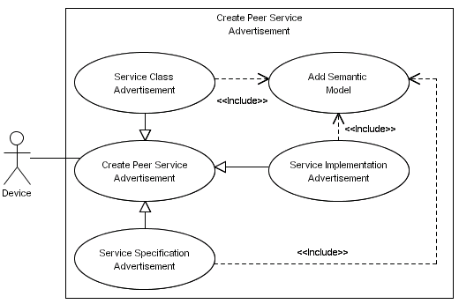
Figure 6 Create Peer Service Advertisements

Issues
The issues associated with the Use Case are not known at this stage.

Requirements
Devices will provide optional core peer services and zero or more application specific peer services. Each peer service provided by the device must be described using several service descriptions. A Service Class Advertisement must be created and used to advertise the particular functionality provided by the device. The Service Class must be uniquely identified using a ServiceClassID. A Service Specification Advertisement must be created and used to describe how the service can be connected to and how the functions it provides can be invoked. There may be multiple service specifications, each describing the communication protocols supported by the device and all the service specifications the service uses. This advertisement must be uniquely identify using a ServiceSpecificationID and linked to the Service Class using the ServiceClassID. The Service Implementation Advertisement must be created and used to describe the implementation of a particular service specification. Their may be multiple Service Implementation Advertisements, each describing how a particular service specification is implemented. The Service Implementation Advertisement must be uniquely identified using the ServiceImplementationID and must be associated with a Service Specification Advertisement using the ServiceSpecificationID. The Service Interface must be added to the Service Implementation Advertisement – this can be explicitly inserted into the advertisement or a link can be provided where the Service Interface can be retrieved.
The Service Profile Model must be added to the Service Class Advertisement, the Service Process Model must be added to the Service Specification Advertisement and the Service Grounding Model and the Service Interface must be added to the Service Implementation Advertisement – although there are several Service Specifications the same Service Process model will be added to them all. This is not the case for the Service Grounding as the semantics of this model are explicitly mapped onto signatures in the service interface. As such there will need to be a new Service Grounding Model for each service technology being used. These service models are described in the “Create Semantic Advertisements” Use Case.
Discovering services within this framework must be based on service capability matching using the Service Advertisements and Service Models described above, to implement significant advantages over existing attribute-based service discovery mechanisms.

Actors/Roles
The actors within this Use Case are as follows:
- Device: Before a device publishes a Peer Service it wishes to share in the P2P network it is responsible for creating the Service Class Advertisement, one or more Service Specification Advertisements and one or more Service Implementation Advertisements. Services within this framework are discovered based on capability matching, which uses semantic descriptions and the Service Interface therefore these descriptions must be appended to the service advertisements. Once these advertisements have been created the device will publish them locally and remotely within the P2P network.

Goals/Context
Within this Use Case there are a number of goals that need to be addressed depending on the particular actor involved.
- Create Service Class Advertisement: The device must create this advertisement to advertise a particular behaviour the device wishes to share. This advertisement must be uniquely identified and used to group all the associated Service Specification Advertisements it has.
- Create Service Specification Advertisement: The device must create this advertisement to describe how devices bind to the service and how the methods it provides are invoked.
- Create Service Implementation Advertisement: This advertisement must describe the implementation details for a particular service specification advertisement.
- Append Service Interface to Service Implementation Advertisement: Services within this framework must be discovered based on capability matching using service ontologies that bind to the Service Interface. Consequently the Service Interface must be appended to the Service Specification Advertisement. This can be achieved by explicitly adding the Service Interface or by providing a link that allows the Service Interface to be downloaded.
- Append Service Ontologies to Service Advertisements: The service ontologies used to describe the service capabilities must be appended to the Service Advertisements. Again this can be achieved by explicitly appending the service ontologies to the advertisement or by providing a link that allows the service ontologies to be downloaded. The Service Profile must be appended to the Service Class Advertisement to allow the capabilities of services to be described. The Service Process Model must be assigned to the Service Specification Advertisement to describe the methods supported by the service at an abstract level. The Service Grounding Model must be appended to the Service Implementation Advertisement, which maps the abstract method descriptions onto concrete signatures in the Service Interface.
- Publish Advertisements Locally and Remotely within the P2P Network: Once all the advertisements have been created they must be published within the peer’s local cache and remotely within the P2P network.

Assumptions
The assumptions for this Use Case are not known at this stage.

Scenario/Steps
The device will provide zero or more core peer services including several application specific peer services. Each peer service must have a number of associated advertisements that describe the peer service has a whole. The device begins by identifying all the peer services it has and for each service it creates a Service Class Advertisement, one or more Service Specification Advertisements and one or more Service Implementation Advertisements. A service my have several Service Specifications and several Service Implementations therefore a new advertisement must be created for each specification and implementation the service supports. Services Advertisements must contain the Service Interface, depending on the service technology being used – for example if Web Services are used then the WSDL file will be appended to the Service Implementation Advertisement. Furthermore the service ontologies used to describe the services capabilities are added to the advertisements, which form an explicit binding to the Service Interface. Once all advertisements have been created the peer service advertisements are published locally in the peer’s cache and remotely within the P2P network.

Extensions
The Service Class Advertisement does not only advertise the existence of the service but it also allows all the service specifications to be collected and explicitly associated with a particular type of service using the ServiceClassID. The Service Specification Advertisement also brings with it confusion and it may be argued that only one specification is required. However this limits the flexibility of the framework as a whole. The framework must be flexible enough to incorporate multiple communication protocols and furthermore the implementation of these protocols must not be constrained to one particular standard. Consequently devices must describe the communication specifications they support and the various implementations of those specifications they provide. This will allow other devices within the network to make decisions regarding what services they wish to discover including the choice of specific specifications and their associated implementations.

Use Case: Publish Peer Service

Description
This Use Case illustrates how Peer Services are published locally and remotely within the P2P network in this framework. The Use Case diagram is illustrated in Figure 7.
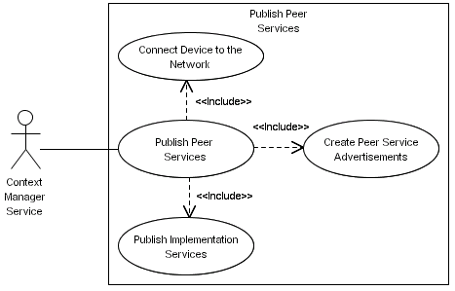
Figure 7 Publish Peer Service

Issues
The issues associated with the Use Case are not known at this stage.

Requirements
For each Peer Service provided by the device several advertisements need to be developed that provide high level information about the service, such as creator details, including specification and implementation details. Peer Services expose the functionality provided by the device as independent services - these services must be described and published in order to allow other devices within the network to discover them based on a particular service’s capabilities. Consequently service advertisements need to be created and published locally within the devices cache and remotely within the P2P network.

Actors/Roles
The actors within this Use Case are as follows:
- Device: The device within this Use Case creates several service advertisements that describe a Peer Service from a number of viewpoints. Once these advertisements have been created the device publishes them locally within the devices cache and remotely within the P2P network.

Goals/Context
Within this Use Case there are a number of goals that need to be addressed depending on the particular actor involved.
- Publish Peer Services: A device needs to publish the Peer Services it provides using advertisements, which exposes the devices capabilities and enables other devices to discover these services and reason over whether they can be used.

Assumptions
This Use Case assumes that semantic service advertisements are described using an RDF(S) based ontology languages. This is the base requirement, however we assume that more expressive ontology languages will be used such as DAML+OIL or OWL - this decision is left to the device manufacturer.

Scenario/Steps
When the device is initially started it begins by creating the Peer Service Advertisements. When all the advertisements have been created the device publishes them locally within the devices cache and remotely within the P2P network.

Extensions
No extensions to the details defined above are known at this stage.

Use Case: Create Semantic Service Models

Description
This Use Case illustrates how semantic service descriptions are created by devices, which are explicitly mapped to Service Interfaces. The Use Case diagram is illustrated in Figure 8.
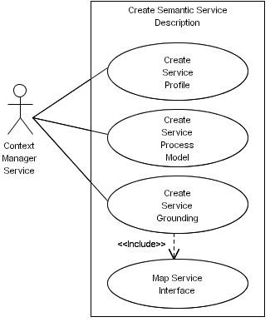
Figure 8 Create Semantic Service models

Issues
The issues associated with the Use Case are not known at this stage.

Requirements
Each service provided by a device needs to be described in such a way that other devices can understand services in terms of their capabilities. In order to achieve this, services need to be described using machine-processable semantics that capture the capabilities from a number of viewpoints. The collective combination of these descriptions must allow services to be automatically discovered, composed and executed, without any human intervention. A Service Profile Model must be created that allows the service to be discovered based on the capabilities the profile describes. Within the framework service requests are the same as service profiles – in this instance if a service request matches the descriptions in the service profile then a capability match has been found. A Service Process Model must be created that groups all the IOPEs in the Service Profile into associated Atomic Processes. An Atomic Process can be thought of as a signature or a method that describes the inputs a method requires and the output it generates. In turn these Atomic Processes must be described and mapped to Atomic Process in the Service Grounding. These Atomic Processes must form explicit bindings to the methods in the Service Interface. Consequently a Service Grounding and a Service Interface need to be created.

Actors/Roles
The actors within this Use Case are as follows:
- Device: When the device is started it will deploy the implementation services it provides and then publish the peer services that map onto the implementation services. The device will ensure that each peer service is semantically described. This will either be achieved by loading service descriptions from the device’s persistent storage or via the code itself. The service advertisements that are created are inserted into the peer service advertisements (the Service Class Advertisement, the Service Specification Advertisement, and the Service Implementation Advertisement), which are published locally and remotely within the P2P network.

Goals/Context
Within this Use Case there are a number of goals that need to be addressed depending on the particular actor involved.
- Create the Service Profile: For each Peer Service the device provides it must create an associated Service Profile that allows the Peer Service to be semantically described and discovered. The Service Profile must describe the service in terms of the Inputs the service supports the Outputs it generates, including any Preconditions that must be satisfied and the Effects produced when the service is executed – these are known as the IOPEs.
- Create the Service Process Model: Each Peer Service must have an associated Service Process Model, which describes the Atomic Processes the service supports. An Atomic Process can be thought of as a method. Each Atomic Process will contain zero or more Inputs and one Output if a value is returned. All the Inputs and Outputs defined in the Service Profile will be associated with Atomic Processes in the Service Process Model.
- Create the Service Grounding: A Service Grounding must be created that contains Atomic Processes that are associated with the Atomic Processes in the Service Process Model.
- Map the Service Grounding to the Service Interface: The Atomic Processes in the Service Grounding must be explicitly mapped onto signatures contained in the Service Interface.

Assumptions
The assumption within this Use Case is that semantic service descriptions are described using RDF(S) based metadata languages. An Ontology needs to be used in conjunction with a Semantic Interoperability Bridge to resolve conflicts between different vocabularies.

Scenario/Steps
When the device is switched on and the implementation services have been published, the device will semantically describe and publish the Peer Services that map onto the implementation services. Before the Peer Service is published the device will create the Service Profile Model, the Service Process Model and the Service Grounding Model. These descriptions can be either loaded from the devices persistent storage, created from serialised objects or from within the code itself – this decision is left to the device manufacturer. The IOPEs in the Service Profile Model are associated with corresponding Atomic Processes in the Service Process Model. These Atomic Processes are associated with Atomic Processes in the Service Grounding, which themselves are associated with concrete signatures described in the Service Interface. Once the semantic descriptions have been created they are appended to the Service Specification Advertisement. This ensures that the semantic descriptions are published along with the Peer Service Advertisements so that when Peer Services are discovered, the service requester can use the semantic information to determine if any of the services the device provides supports the required capabilities.

Extensions
No extensions to the details defined above are known at this stage.

Use Case: Find Core Services

Description
This Use Case illustrates how a device finds core service advertisements located on the device and distributed within the P2P network. The Use Case diagram is illustrated in Figure 9.
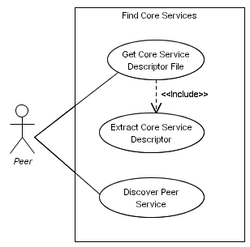
Figure 9 Find Core Services

Issues
The issues associated with the Use Case are not known at this stage.

Requirements
Within this framework there are four core services called the Distributed Emergent Semantics (DistrES) service [3], the Semantic Interoperability and Signature Matching (SISM) service [4], the Device Capability (DeCap) [4] service, and the Context Manager (ConteM) service [8]. A device, depending on its capabilities may choice to implement zero or more of these core services. If the device does not choice to implement these services then they must be discovered within the P2P network and bound to before the device can fully integrate itself into the network. We envisage that a plethora of service-enabled networked appliances will be integrated into the network ranging from sensors and microcontrollers to high specification personal computers. Therefore some devices may not have the capability to explicitly host core services due to memory and processing constraints. This being the case the framework provides a level of flexibility that allows the device to still have access to the core functions, but the processing will be performed remotely by other more capable devices. Consequently when the device is switched on it must determine what core services it has and bind to them. Any service that is not explicitly hosted by the device must be discovered within the P2P network and bound to. Only when all the core services have been discovered and bound to will the device be fully functional.

Actors/Roles
The actors within this Use Case are as follows:
- Peer: When the device is started it must bind to all the required core services. The peer binds to all the core services it hosts itself, and if required, it discovers and binds to the remaining services within the P2P network.

Goals/Context
Within this Use Case there are a number of goals that need to be addressed depending on the particular actor involved.
- Load Core Service Descriptor File: Each of the core service descriptions are described in a core service descriptor file. This file must be loaded by the peer once the device has been started.
- Extract Core Services: The descriptor file contains all the service descriptions – the peer must iterate through these core service descriptors and extract each one in turn.
- Discovery Peer Service: Each of the extracted core service descriptors must be used to discover Peer Services locally and remotely within the P2P network – when a service is found it must be bound to.

Assumptions
The assumption is that each core service used in described in a descriptor file. We have described the four core services that are need within this framework, however the device manufacturer is free to describe other core services they deem important. Furthermore the device manufacturer may choose some other mechanism to represent core service descriptions – for example they could be hard coded into the logic. The core service descriptor file could even be accessed via some http address on a remote server. This decision is left to the device manufacturer.

Scenario/Steps
When the device is started it begins by discovering and binding to the core services required within the framework. The device begins by trying to discover the DistrES service locally – this means that the device hosts its own copy of the DistrES service. If the device does not host the service then it tries to discover the service remotely within the P2P network – if the service is discovered it is bound to. Once the DistrES service is bound to this provides the peer with the ability to resolve terminology differences between different vocabularies. The peer then discovers the SISM service using the same procedure described above – it first tries to discover the service locally and if no service exists the peer tries to discover the service remotely within the P2P network. Once this service is bound to this provides the peer with the ability to process semantic service requests and perform semantic matching of IOPEs contained in service requests and service descriptions. The next service the peer discovers is the DeCap service. Once this service has been discovered and bound to this provides the peer with the ability to perform device capability matching. Service requests will contain the device capability requirements needed to effectively execute the service using the data provided by the service requester. This service will allow the peer to match the device capabilities in the service request with the device capability advertisement provided by the device. The last service to be discovered is the ConteM service. This service allows the peer to process any Context Templates the device has and bind the semantic hooks they contain with application specific peer services either found locally or remotely within the P2P network. Once all these services are bound to the device is equipped to effectively function within the network.

Extensions
Devices may integrate themselves within the network to provide specific services only. For example an organisation may specialise in ontology evolution and merging and as such only host the DistrES service and discover all remaining core services remotely. This device may not be interested in providing application specific peer services only the DistrES core service, which it specialises in. One possible motivation for this could be cost, whereby each transaction performed using the DistrES service incurs a small monetary payment for service usage. Although the intended use for this framework is to interconnect service-enabled network appliances, we envisage that many organisations will publish services purely for monetary recompense rather than offering application specific peer services. Based on this assumption the framework provides a level of flexibility that gives device manufactures and service providers a platform that allows them to decide how they will operate within the network.
We have not described how an advertisement is selected from several candidate services. One possibility would be to select the first advertisement in the collection. A second more attractive option would be to select an advertisement based on the capabilities of the service provider, i.e. how effectively the device can provide the service. In this instance an extra step is required that discovers the service provides device capability advertisement and uses it to determine what capabilities the device supports before committing to using the services it provides.

Use Case: Retrieve Context Templates

Description
This Use Case illustrates how Context Templates are retrieved and processed within this framework. The Use Case diagram is illustrated in Figure 10.
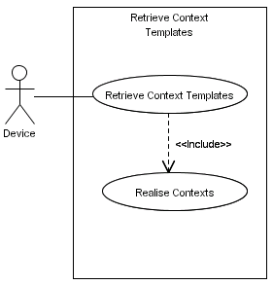
Figure 10 Retrieve Context Templates

Issues
The issues associated with the Use Case are not known at this stage.

Requirements
When the device is started it must retrieve all the Context Templates for the device from some persistent storage. Each Context Template must contain a number of semantic hooks that describe what other services are required. For example a DVD Player may have a Home Entertainment Theatre System Context Template that has semantic hooks for a visual display service and an audio service. Before the context can be executed these services need to be discovered and bound to. The semantic hooks within a context template are equivalent to service requests used in the P2P network, which describes the required service in terms of its capabilities. The ConteM service must extract these semantic hooks and propagate them within the P2P network in order to discover application specific peer services. The semantic hooks and how they are combined in a Context Template can be thought of as rules that define how the device and the services it provides may be used.

Actors/Roles
The actors within this Use Case are as follows:
- Device: The device retrieves the Context Templates and passes them to the ConteM Service, which realises each Context Template the device has. The ConteM Service discovers application specific peer services and binds them to the semantic hooks described in the context templates. This service also manages the lifetime of the services being used and automatically discovers alternative services in the event of a service becoming unavailable.

Goals/Context
Within this Use Case there are a number of goals that need to be addressed depending on the particular actor involved.
- Retrieve Context Templates: The Device must retrieve the Context Templates from some persistent storage – these may be located on the device itself, some external server or within the service logic.
- Realise Context Template: The ConteM Service must realise the Context Template by extracting the semantic hooks it contains and using them to discover application specific services locally or within the P2P network.

Assumptions
The assumption is that each core service used must be described in a descriptor file. We have described the four core services that are needed within this framework, however the device manufacturer is free to describe other core services they deem important. Furthermore the device manufacturer may choose some other mechanism to represent core service descriptions – for example they could be hard coded into the logic. The core service descriptor file could even be accessed via some http address on a remote server. This decision is left to the device manufacturer.
Another assumption within this Use Case is that Context Templates are described using a RDF(S) based metadata language. An ontology needs to be used in conjunction with a semantic interoperability bridge to resolve conflicts between different vocabularies.

Scenario/Steps
The device first checks to see if it uses any Context Templates. If context templates are used, they are retrieved and passed to the ConteM service, which in turn realises them. Each of the semantic hooks contained within a particular Context Template are extracted and used to discover application specific Peer Services locally and within the P2P network. Only when all the semantic hooks within a Context Template have been realised, can the Context Template be used.

Extensions
If the ConteM service is used locally then the Context Templates could be retrieved from the persistent storage. However if the service is used remotely the device would need to retrieve the Context Templates and pass them as a parameter to the ConteM service. Therefore the device retrieves the Context Templates instead of the ConteM service – the remote ConteM service will not have access the persistent storage for another device for security reasons. When the Context Template is processed in this way the remote ConteM service will return the Context Template with all the semantic hooks bound, if all the services could be discovered. Any management functions that need to be performed on the Context Template will require that the Context Template be passed to the remote ConteM service, where the Context Template will be managed and a fresh Context Template will be returned to the device. For example the Context Template may be sent to the remote ConteM service in order to check the TTL values for each of the services used in the semantic hooks. Any expired services will either be refreshed with new TTL values or alternative services will be discovered. After this management process is complete a new Context Template will be returned to the service requester. Consequently, it is envisaged that the device will retrieve the Context Templates and pass then to the ConteM service, whether the service is local or remote.

Use Case: Realise Context Templates

Description
This Use Case illustrates how Context Templates are realised using local and/or remote application specific Peer Services. The Use Case diagram is illustrated in Figure 11.
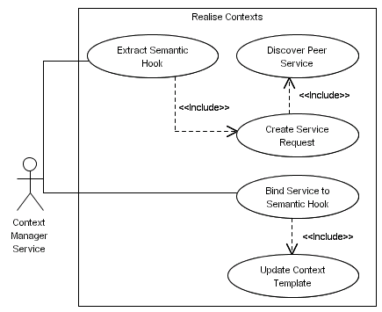
Figure 11 Realise Context Templates

Issues
The issues associated with the Use Case are not known at this stage.

Requirements
A device may have zero or more Context Templates. This is a configurable feature that is left to the device manufacturer. Device manufacturers will initially define some base configurations that allow the device to be integrated within the environment, however we envisage that these templates can be modified by the device owner or new ones can be downloaded from the Internet that describe new possibilities in which the device may be used.
The ConteM Service must process all the Context Templates supported by the device and try to bind services with all the semantic hooks they contain. Only when a Context Template has all the required bindings, can it be used to execute a particular composition of services to perform some required behaviour.

Actors/Roles
The actors within this Use Case are as follows:
- Context Manager Service: The Context Manager Service within this Use Case processes all the Context Templates and tries to bind services with all the semantic hooks by either discovering these services locally or remotely in the P2P network.

Goals/Context
Within this Use Case there are a number of goals that need to be addressed depending on the particular actor involved.
- Extract Semantic Hooks: When a Context Template has been retrieved all the semantic hooks must be extracted. These semantic hooks must define the required services needed to realise the context.
- Create Service Request: When a semantic hook is extracted it must be wrapped in a service request and propagated within the P2P network.
- Discover Peer Service: The service requests created will be used to discover application specific Peer Services.
- Bind Service to Semantic Hook: All the candidate services found must be inserted into the Context Template and related to the relevant semantic hook – if more than one service exists then a list of service bindings will be inserted into the Context Template for the specific semantic hook. This requirement allows an alternative service within the list to be selected in the event of a service failure, which ensures that services do not need to be discovered all over again. This feature is designed to enhance the performance of the system. When all the semantic hooks have been realised, mark the context as complete, indicating that the context template can be used.

Assumptions
This Use Case assumes that there are zero or more Context Templates. Devices do not have to implement Context Templates if the device provides simple behaviours.
Another assumption within this Use Case is that Context Templates are described using a RDF(S) based metadata language. An ontology needs to be used in conjunction with a semantic interoperability bridge to resolve conflicts between different vocabularies.

Scenario/Steps
The device will load all the Context Templates associated with the device and pass them to the ConteM Service. For each Context Template retrieved the device will check to see if the semantic hooks in the Context Templates have services already bound to them. If a binding is found the ConteM Service checks to see if the TTL value for the service has expired. If it has it will attempt to renew the TTL values for each service and update the Context Template. All services that cannot be renewed will be removed from the semantic hooks. At any one time a semantic hook can have a number of associated services however it can only have one binding at any one time. If a service fails or if the TTL value expires and cannot be renewed, the device will attempt to use an alternative service associated with the semantic hook.
The ConteM Service binds services to the semantic hooks by extracting the semantic hook information and formulating a service request, which is used to find services locally. If no local service is found the service request is submitted to the P2P network. All successful services that are found are associated with the semantic hook in a particular Context Template however, as described above only one service is bound to the hook at any one time. The remaining services will act as supporting services that can be used if the current service binding fails. When a semantic hook has a successful binding the Context Template is updated and the process continues until all the hooks within the Context Template have successful bindings. When this occurs the Context Template may be executed by the device or the device owner.

Extensions
No extensions to the details defined above are known at this stage.

Use Case: Discover Peer Service

Description
This Use Case illustrates how Peer Services are discovered within this framework. The Use Case diagram is illustrated in Figure 12.
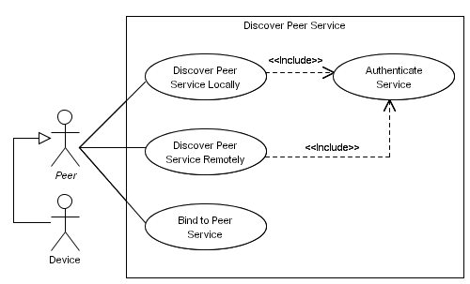
Figure 12 Discover Peer Service

Issues
The issues associated with the Use Case are not known at this stage.

Requirements
When a device is started it must discover and bind to several core Peer Services it requires which must be discovered locally or remotely within the P2P network. Before a device commits to using a service it must first be authenticated to verify the service provider. How this is achieved is dependent on the device manufacturer’s security policy.

Actors/Roles
The actors within this Use Case are as follows:
- Device: The Peer interface implemented on the device contains a discovery service that allows it to discover the Peer Services locally and remotely within the P2P network.

Goals/Context
Within this Use Case there are a number of goals that need to be addressed depending on the particular actor involved.
- Discover Peer Services Locally: The device must first try to discover the required Peer Services locally.
- Discover Peer Services Remotely: If the device does not find a Peer Service locally then it must try and discover the Peer Service remotely within the P2P network.
- Authenticate Service: Any candidate service that is discovered must be authenticated to ensure that the service provider is trusted.
- Bind to Peer Services: When Peer Services are discovered, the device must bind to the service so that it can be used.

Assumptions
The framework assumes that all services will be authenticated before they are used to ensure that only services provided by trustworthy service providers are used. How the device manufacturer performs this authentication is dependent on the security policy being used, however the framework authentication interfaces must be implemented.

Scenario/Steps
When the device is first started it creates a peer instance that connects the device to the P2P network and provides it with the mechanisms to discover and bind to Peer Services. The device determines what Peer Services are required – this will include core Peer Services and application specific Peer Services. For each service it requires it will begin by first trying to discover the Peer Service advertisement locally within the devices cache. If the service advertisement cannot be found, the device attempts to discover the Peer Service advertisement remotely within the P2P network. For each Peer Service that is found the peer binds to it. When a candidate service has been discovered it is authenticated to ensure that the service provider is trustworthy.

Extensions
No extensions to the details defined above are known at this stage.

Use Case: Invoke Peer Service

Description
This Use Case illustrates how Peer Services are invoked within this framework. The Use Case diagram is illustrated in Figure 13.
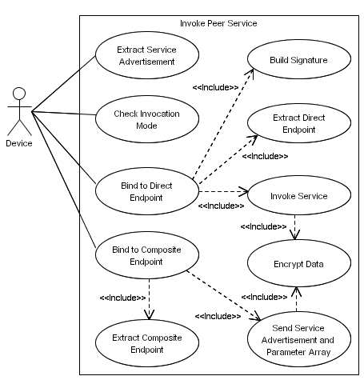
Figure 13 Invoke Peer Service

Issues
The issues associated with the Use Case are not known at this stage.

Requirements
The services provided by devices must form compositions with other services over time as they integrate themselves within the environment. Devices must retrieve the service advertisements for each service they wish to invoke and begin by checking the connection mode the service supports. If the connection mode is direct then the service can be directly invoked without the help of any intermediary services. In this instance the signature must be built, the endpoint for the service must be extracted, the data passed to the service must be encrypted and the service must be invoked. If the connection mode is composite, then this means that the service can only be invoked using intermediary services. In this instance the extended interface file must be extracted from the service advertisement and the extended interface endpoint must be extracted and used to bind to the service. Once the service has been bound to the extended interface file and the require parameters must be encrypted and passed to the service. When this information is received the service must extract the service advertisement for the intermediary service and again determine what the connection mode is and the above requirements must be repeated until an intermediary service is found that supports a direct connection. When a direct connection mode is found this means that we have reached the end of the composition chain. Once the final intermediary service has been located it must be executed and the results must be returned back up the composition chain until the final result reaches the initial service requester.

Actors/Roles
The actors within this Use Case are as follows:
- Device: The device processes service advertisements and connects to services depending on the connection mode defined in the service advertisement. Any results returned are either used internally or returned to the initial service requester.

Goals/Context
Within this Use Case there are a number of goals that need to be addressed depending on the particular actor involved.
- Extract service advertisement: The device must extract the service advertisement, which may be retrieved from the devices persistent storage or via a particular Context Template.
- Check invocation mode: Once the service advertisement has been retrieved the device must check the connection mode. This will allow the device to decide whether the service can be directly invoked or indirectly invoked using intermediary services.
- Execute the service in direct mode: If the connection mode is direct the device must build the signature, extract the direct endpoint, bind to the service, encrypt the data and then invoke the service.
- Encrypt Data: Before any data is sent to a service it must be encrypted. This framework does not place any constraints on how this is achieved and is dependent on the device manufacturer’s security policy.
- Execute the service in composite mode: If the connection mode is composite the device must extract the extended interface file from the service advertisement including the composite endpoint and bind to it. The extended interface, including the array or parameters, must encrypted and passed to the intermediary service.

Assumptions
How data is encrypted is dependent on the device manufacturer’s security policy. This framework does not place any constraints on how this is achieved, however the data encryption interfaces provided by the framework must be implemented.

Scenario/Steps
The device begins by processing a service advertisement to determine the connection mode. If the connection mode is direct then the direct endpoint is extracted and used to bind to the service, the signature is built and the required data is encrypted before the service is invoked. The results returned from the invocation are either used internally or passed to the initial service requester. If the connection mode is composite then the extended interface file is extracted from the service advertisement including the composite endpoint. Using the composite endpoint the service is bound to and the extended interface file and the array of parameters required to invoke the service are encrypted before they are passed to the service. This process continues for all the intermediary services used in the composition chain until the chain finally ends when a direct connection mode is determined. The results from each execution in the composition are propagated back up the chain and used internally by intermediary services to perform the required data type conversions. The results from these conversions are themselves propagated back up the composition chain. This process continues until the service requester at the top of the chain receives the result – note return values may not be required, i.e. the device at the top of the chain might be a DVD play that requires a service to process the audio stream. In this instance the DVD player does not require a return value.

Extensions
No extensions to the details defined above are known at this stage.

Use Case: Process Service Request

Description
This Use Case illustrates how a device processes a service request received from the P2P network within this framework. The Use Case diagram is illustrated in Figure 14.
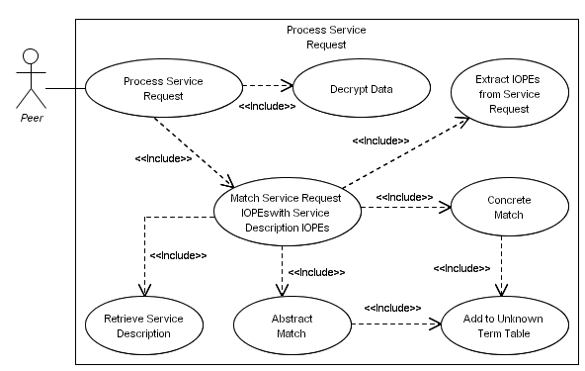
Figure 14 Process Service Request

Issues
The issues associated with the Use Case at not known at this stage.

Requirements
Devices within the P2P network will receive service requests from other devices requesting services that perform a specific function. Devices need to process service requests and extract the semantic information that defines the required behaviour a particular service must provide. The information extracted will be encrypted consequently the data needs to be decrypted before it is processed. This semantic information needs to be matched with the semantic information contained in the service description for each service provided by the device. The semantic information must be based on the Inputs taken by a candidate service, the Output it returns, the Preconditions required by the service and the Effects that happen as a result of executing the service, which are known as IOPEs [9]. The matching process itself needs to match services using abstract matching and concrete matching. The requirements described in the service request may match at the abstract level, which provides an indication that the current service being processed is a candidate service. However a successful match can only be determined if the requirements in the service request match signatures defined in the service interface – we call this a concrete match. In the framework we provide a level of flexibility and allow the abstract matching functionality to be used for semi-automatic service composition and concrete matching for dynamic service composition.
It is inevitable that the vocabularies used within service requests and service descriptions will differ. We do not place any constraints on the vocabulary used, therefore the framework needs to provide semantic interoperability mechanisms that allow the matching process to determine whether terms that are syntactically different are semantically equivalent. Any terms that are not known by the device must be added to an Unknown Term Table. The terms within this table can either be propagated within the P2P network in real-time in order to discover other peers that know the concept that defines the term or this can be an off-line process that is performed when the device is idle. The device must never the less always try to resolve ambiguities between terms and evolve its own internal knowledge structures over time to ensure that it can better integrate itself within the environment and understand the terminology used by other devices. It is important that both the terms being processed are propagated within the network because the device is trying to determine if a relationship between the two terms exists.

Actors/Roles
The actors within this Use Case are as follows:
- Peer: The device within this Use Case receives service requests from the P2P network, which are processed to determine if the device offers any services that semantically match the requirements defined in the service request and a service description associated with a particular service the device provides.

Goals/Context
Within this Use Case there are a number of goals that need to be addressed depending on the particular actor involved.
- Process service requests: Devices must process requests received from the P2P network. The service requests themselves will be described using machine-processable semantics using IOPEs [9]. IOPEs must be extracted from the service request and matched against the IOPEs in the service description (also known as the Service Profile).
- Decrypt Data: The service request will contain encrypted data consequently all data must be decrypted before it is processed. How this is achieved is dependent on the security policy used by the device manufacturer.
- Extract IOPEs: Service requests and service descriptions are described using IOPEs therefore the Matching algorithms must be passed the extracted IOPEs from the service request and the service description.
- Abstract match service requests: Service requests describe the type of service required in terms of the candidate service’s capabilities. Abstract matches match service descriptions with service requests based on high level concepts using IOPEs. This feature may be used for semi-automated service composition, whereby this feature provides a semantic search engine of ad hoc services. However we envisage that it will be used to index and locate services provided by the device – any candidate services will then be processed to determine it the IOPEs in the service request can be mapped onto concrete signatures described in the service interface.
- Concrete match service requests: Services that are matched at the abstract level are classed as candidate services and when used in dynamic service composition architectures, they will be further processed in order to determine if the requirements defined in the service request can be explicitly mapped on to signatures described in the service interface.
- Perform semantic interoperability: The terminology used in service requests and service descriptions will differ, therefore semantic interoperability mechanisms need to be provided that enables the device to determine if syntactically different terms are semantically equivalent. Any terms that are not known must be propagated to the P2P network. This will result in several knowledge structures that describe the concept, which must be evolved using a general consensus found within all the structures [3]. The unknown terms can be either propagated within the P2P network in real-time as the ambiguity arises or this can be performed as an off-line housekeeping function when the device is not in use. This decision is left to the device manufacturer.

Assumptions
How data is decrypted is dependent on the device manufacturer’s security policy. This framework does not place any constraints on how this is achieved, however the data decryption interfaces provided by the framework must be implemented.

Scenario/Steps
When a device receives a service request from the P2P network it initially decrypts the data and extracts the IOPEs from the service request. Once the IOPEs have been extracted the device retrieves the service description from the local cache and checks to see if the IOPEs in the service request can be abstractly matched with the IOPEs in the service description. If an abstract match is found, the IOPEs in the service request are further processed to see if a signature within the service interface exists that supports the required Inputs and produces’ the required Output, which also matches the associated data types. It a match is found this is classed as a concrete match, and a service advertisement is returned to the querying device.
During the abstract and concrete matching process the device uses semantic interoperability mechanisms to resolve terms that are syntactically different but semantically equivalent. This is an important requirement because it is inevitable that the vocabulary used in service requests and service descriptions will be different. In this instance the peer will extract the conflicting IOPE from the service request and the conflicting IOPE from the service description. Both of these IOPEs will be propagated within the P2P network and only concepts that describe a relationship between the two terms will be returned to the querying peer. The semantic structures returned from this process will be evolved using general consensus and merged with existing structures within the peer’s knowledge base [3].

Extensions
No extensions to the details defined above are known at this stage.

Use Case: Perform Semantic Interoperability

Description
This Use Case illustrates how the matching algorithms perform semantic interoperability between terms that are syntactically different but semantically equivalent within this framework. The Use Case diagram is illustrated in Figure 15.
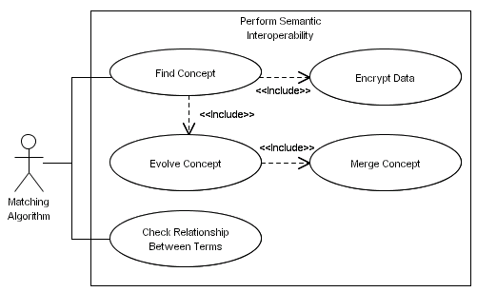
Figure 15 Perform Semantic Interoperability

Issues
The issues associated with the Use Case at not known at this stage.

Requirements
This framework does not place any constraints on the vocabulary used to describe service requests and service descriptions. The base assumption is that different vocabularies will be used and as a result mechanisms need to be developed that provide interoperability between different terms. Semantic interoperability will be achieved by either using an ontology stored on the device or a remote ontology provided as a service by another device located within the P2P network. Many devices will contain and offer ontology services, depending on their capabilities, which collectively form distributed knowledge base systems within the P2P network devoid of any centralisation. The ontologies themselves are dynamic and will continually evolve over time based on general consensus; consequently the most common concepts will be propagated throughout the network over time. Therefore mechanisms are required that allow concepts to be exchanged between devices within the P2P network, and mechanism that allow multiple concepts to be evolved based on general consensus and merged into the devices local ontology [3].

Actors/Roles
The actors within this Use Case are as follows:
- Matching Algorithm: The matching algorithm can either be the abstract matcher or the concrete matcher. These algorithms use distributed ontologies to resolve any ambiguities found between terms found in the IOPEs described in the service request or the service description.

Goals/Context
Within this Use Case there are a number of goals that need to be addressed depending on the particular actor involved.
- Check Relationships between Terms: The matching algorithms match the requirements defined in the service request with the capabilities described in the service description. During the matching process terms are matched and if they are syntactically different, the algorithm must use the ontology to determine if a semantic relationship exists that links the terms together.
- Find Concepts: If the matching algorithm does not find a relationship between terms it must formulate a service request and propagate it within the P2P network in order to try and find devices that contain semantic structures that link the two terms together. This will result in zero or more concepts being returned to the querying device defining the conceptual meaning of the terms.
- Encrypt Data: Data transferred between peers must be encrypted. How this is achieved is dependent on the device manufacturer’s security policy.
- Evolve Concepts: When several concepts are returned to the querying device, the concepts themselves will be subjective based on the opinions of a device’s ontology. Therefore the device needs to evolve the concepts in order to extract the common terms and relationships within the structures that will result in a new structure that is said to capture the general consensus.
- Merge Concepts: When an optimal ontology has been evolved it must be merged into the devices local ontology.

Assumptions
How data is encrypted is dependent on the device manufacturer’s security policy. This framework does not place any constraints on how this is achieved, however the data encryption interfaces provided by the framework must be implemented.
Another assumption within this Use Case is that the service requests and the service descriptions are described using RDF(S) based metadata languages.

Scenario/Steps
The device passes a service request to the Abstract and Concrete Matching Algorithms and the terms in the service request are matched with the terms in a service description. If two terms are syntactically equivalent then this is an exact match. However if the terms are syntactically different the matching algorithms use the ontology to try and determine if a relationship exists that links the two terms together – for example ‘X’ is a subclass of ‘Y’. If a relationship exists then it is possible that the two terms are semantically equivalent, which constitutes a match. If the terms do not syntactically or semantically match, then the algorithm formulates a concept request message containing the terms, encrypts it and propagates it within the P2P network. The device can either perform this function in real-time or as an offline function when the device is not in use.
When the request message is sent this will result in zero or more responses dependent on devices having concepts that link the two terms together. The responses will define the concept differently therefore the concepts are evolved to retrieve the most common terms and relationships that exist within all the structures. Once an optimal concept has been produced the new structure will be merged into the devices local ontology.

Extensions
No extensions to the details defined above are known at this stage.

Use Case: Perform Abstract Match

Description
This Use Case illustrates how the Abstract Matching Algorithm matches the Inputs, Outputs, Preconditions, and Effects (IOPEs) found in both the service request and the service description within this framework. The Use Case diagram is illustrated in Figure 16.
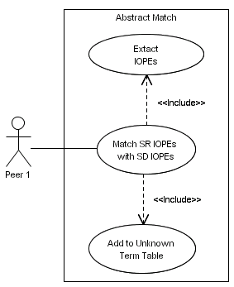
Figure 16 Perform Abstract Match

Issues
The issues associated with the Use Case are not known at this stage.

Requirements
Within this framework devices must be capable of discovering services based on their capabilities. The Abstract Matching algorithm must be capable of matching service requests with service descriptions (Service Profile) based on high level concepts. This algorithm must process a service request and service description and determine if all the IOPEs in the service request match IOPEs in the service description. If they do then this is classed as an abstract match. This algorithm is designed to enable the device to filter through services based on capability matching and typically this function, when used alone, would enable semi-automatic service composition. Although the services may be abstractly matched the device manufacturer has to look at the service interfaces to determine if a signature exists that takes the required inputs and returns the required output as described in the service request. If automatic dynamic service composition is required then this algorithm must be used with the Concrete Matching Algorithm.

Actors/Roles
The actors within this Use Case are as follows:
- Abstract Matching Algorithm: The Abstract Matching Algorithm processes all the IOPEs in a service request and a service description and determines if a match between the two can be determined.

Goals/Context
Within this Use Case there are a number of goals that need to be addressed depending on the particular actor involved.
- Extract IOPEs from both the Service Request and the Service Description: Before the matching process begins the IOPEs from both the service request and the service description must be extracted.
- Match the IOPEs in the Service Request and the Service Description: The Abstract Matching Algorithm must semantically match the IOPEs in the service request and the service description.
- Perform Semantic Interoperability: If there are terminology differences between terms then the device must use the DistrES Ontology to determine if there is a relationship between the two terms that semantically links them together.

Assumptions
The assumption within this Use Case is that service requests and service descriptions are described using RDF(S) based metadata language. An ontology needs to be used in conjunction with a semantic interoperability bridge to resolve conflicts between different vocabularies.

Scenario/Steps
When the Abstract Matching Algorithm receives a service request it begins by extracting the IOPEs from the service request and service description it has for each peer service it has published. The process begins by trying to determine if all the Inputs in the service request matched the Inputs in the Service Profile. If any conflicts occur the algorithm tries to resolve these conflicts using the semantic interoperability bridge. This process is repeated for the Outputs, the Preconditions and the Effects. Only when all the IOPEs in the service request are matched with IOPEs in the Service Profile does the algorithm conclude that an abstract match has been found – if a match is found the service advertisement is passed back to the device. At this point the device can either return the service advertisement to the service requester or perform further analysis to determine if the service request can be matched at a concrete level.

Extensions
No extensions to the details defined above are known at this stage.

Use Case: Perform Concrete Match

Description
This Use Case illustrates how the Concrete Matching Algorithm matches the Inputs and Outputs found in the service request with concrete bindings found in the Service Interface within this framework. The Use Case diagram is illustrated in Figure 17.
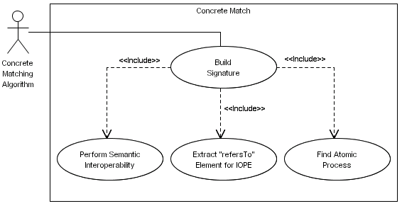
Figure 17 Perform Concrete Match

Issues
The issues associated with the Use Case are not known at this stage.

Requirements
In the “Perform Abstract Match Use Case” we were interested in determining if descriptions in the service request match the capabilities of a particular service described in the service description. Although this mechanism allows use to perform capability matching it still does not allow us to automate the process of dynamically composing ad-hoc services. In order to achieve this we need to process service requests in conjunction with each of the signatures a particular service supports. The Concrete Matching Algorithm must provide mechanisms that allow the IOPEs in the service request to be matched to a single Atomic Process in the Service Process Model. If an Atomic Process is found then a signature exists within the service interface. The Concrete Matching Algorithm must also provide mechanisms that allow the signature to be built using the information found in the Service Grounding Model, which directly maps Atomic Processes onto the signatures defined within the Service Interface. This process is important because at this stage we only know what the IOPEs are – we do not know what the operation name is or the order in which the parameters must appear in the signature. The Build Signature process must use the Service Grounding Model and the Service Interface to achieve this.
An important requirement within this framework is the provision to resolve matching conflicts that occur. If the Concrete Matching Algorithm successfully maps the IOPEs in the service request with signatures in the Service Interface but encounters data type conflicts it must try to resolve these conflicts using intermediary services that can explicitly provide data type conversion services. Contrary to this requirement there may be instances when converting the data type is insufficient and rather the software to achieve this must be downloaded. For example a device may choose to download a particular codec to process some media format rather than converting the data stream in real-time in order to increase or maintain a high quality of service. However less capable devices may choose to outsource the processing to a more capable device.
There will be inherent terminology differences between the terms used in the service request, the service description and the service interface. In this instance the Concrete Matching Algorithm must perform semantic interoperability to determine if the terms are syntactically distinct but semantically equivalent.

Actors/Roles
The actors within this Use Case are as follows:
- Concrete Matching Algorithm: The Concrete Matching Algorithm tries to map the IOPEs in the service request to concrete bindings (signatures) found in the Service Interface. It tries to find a signature that supports all the Inputs and produces the required Output. During this process it also takes into account the data type information associated with each parameter and tries to resolve any conflicts using intermediary services that perform data type conversions. This algorithm must also resolve any ambiguities between terms that are syntactically distinct but semantically equivalent.

Goals/Context
Within this Use Case there are a number of goals that need to be addressed depending on the particular actor involved.
- Find Atomic Processes in Process Model: The Concrete Matching Algorithm must determine if a single Atomic Process exits in the Process Model that supports all the IOPEs in the service request. If an Atomic Process is found then this will indicate that a signature exists in the Service Interface that supports the Inputs and Outputs.
- Find Atomic Processes in Service Grounding Model: If an Atomic Process is found in the Process Model this must be used to find the Atomic Process in the Service Grounding Model. The Atomic Process in the Service Grounding must directly map onto a signature contained in the service interface. The Atomic Process will provide information regarding the operation name, parameter names, parameter data types and parameter order. This will enable the Concrete Matching algorithm to bind to the service interface and determine what order the parameters must appear and what data types they must support.
- Build Signature: Using the Atomic Process in the Service Grounding Model the Concrete Matching Algorithm must build a signature, which will contain the operation name and the parameter order.
- Resolve data type conflicts: During the signature building process the algorithm must check for data type conflicts and use intermediary services to perform indirect data type conversions in order to resolve conflicts.
- Create Service Requests: If a conflict is found then a new service request must be formulated describing the input an intermediary service must support and the required output it must produce. This allows the Concrete Matching algorithm to indirectly perform a data type conversion using intermediary services.
- Find Intermediary Services: Using the P2P Network the Concrete Matching Algorithm tries to find intermediary services that perform data type conversions.
- Perform Semantic Interoperability: There will be inherent terminology differences between terms used in the service request, the service description and the service interface, therefore this algorithm must resolve any ambiguities by determining if terms that are syntactically distinct are semantically equivalent.

Assumptions
The assumption within this Use Case is that the service requests and the service descriptions are described using RDF(S) based metadata languages. An ontology needs to be used in conjunction with a semantic interoperability bridge to resolve conflicts between different vocabularies.

Scenario/Steps
Initially the Concrete Matching Algorithm extracts the IOPEs from the service request and tries to find an Atomic Process in the Service Process Model that supports all the IOPEs. If an Atomic Process exits that accommodates all the Inputs in the service request and produces the required Output then this is classed as a candidate Atomic Process. If an Atomic Process is found in the Process Model it is used to locate a corresponding Atomic Process in the Service Grounding. The Atomic Process in the Service Grounding extends the capabilities of the Atomic Process in the Process Model and provides information that allows a user of the service to execute a signature in the Service Interface. The information contained in the Atomic Process is used to build the signature. The operation name is extracted and the parameter order information is extracted from the service interface using the Service Grounding. During the Signature building process the “Perform Semantic Interoperability” Use Case is used to resolve any terminology differences that may exist between the service request and the service descriptions. Furthermore, the signature building process performs data type checking to determine whether the data types in the service request match the data types in the candidate signature. If a conflict is found then the Concrete Matching Algorithm tries to resolve this conflict by trying to discover a service that can convert one data type to another data type. This requires the algorithm to formulate a service request that contains the conflicting IOPE as an Input and the required data type as an Output. If a signature is successfully built then the service advertisement is returned to the service requester. Any intermediary services that where required will be described in an extended interface file and inserted into the service advertisement before it is returned.

Extensions
No extensions to the details defined above are known at this stage.

Use Case: Build Signature

Description
This Use Case illustrates how signatures are built to determine if a concrete match has been found within this framework. The Use Case diagram is illustrated in Figure 18.
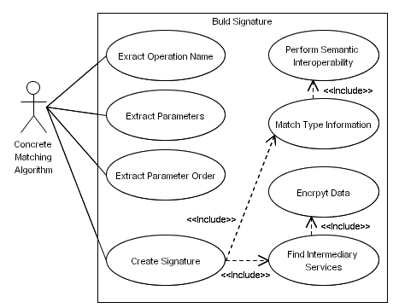
Figure 18 Build Signature

Issues
The issues associated with the Use Case are not known at this stage.

Requirements
The Concrete Matching Algorithm must build signatures using the service request IOPEs to determine if a concrete match has been found. If an Atomic Process in the Service Process Model maps onto a corresponding Atomic Process in the Service Grounding Model, a potential signature in the Service Interface has been found. The Concrete Matching Algorithm extracts the operation name associated with the Atomic Process in the Service Grounding Model from the Service Interface including the parameter names, parameter data types and the parameter order. Once the values have been extracted the algorithm must try to create the signature. When the signature is built the algorithm checks the type information described in the IOPEs in the service request with the data type information for parameters in the signature. The terminology used to describe the IOPEs in the service request may differ to the terminology used in signatures in the Service Interface therefore the semantic interoperability bridge must be used to resolve terms that are syntactically distinct but semantically equivalent. If any data type conflicts are encountered between the service request IOPE data types and the signature parameter data types then the algorithm must first try to resolve these conflicts using intermediary services before it fails. Any intermediary services that are found will be used to perform the data type conversion functions, consequently the intermediary service advertisement is added to the service advertisement before it is returned to the service requester.

Actors/Roles
The actors within this Use Case are as follows:
- Concrete Matching Algorithm: The Concrete Matching Algorithm will build signatures to determine if a concrete match has been found, using the IOPEs in the service request and Atomic Processes associated with these IOPEs in the Service Process Model and the Service Grounding Model. During this process the algorithm must resolve terminology differences between terms that are syntactically distinct but semantically equivalent. If the algorithm determines that there are data type conflicts it must first try to resolve these conflicts using intermediary services before it concludes that no concrete match has been found.

Goals/Context
Within this Use Case there are a number of goals that need to be addressed depending on the particular actor involved.
- Extract Operation Name: The Concrete Matching Algorithm must retrieve the operation name from the service interface for the signature that maps onto the required Atomic Process in the Service Grounding Model.
- Extract Parameters: The Concrete Matching Algorithm must retrieve the parameters from the service interface for the signature that maps onto the required Atomic Process in the Service Grounding.
- Extract Parameter Order: Once the parameters have been extracted the order in which they must appear in the signature must be extracted to ensure that each parameter is placed in the correct position.
- Create Signature: Once all the required information needed to build the signature has been extracted the signature must be built.
- Match Type Information: When the signature has been built the data type information for each Input parameter and the Output parameter must be compared to the data type information for each matching IOPE data type in the service request.
- Perform Semantic Interoperability: The terminology used in service requests, service descriptions and service interfaces are not deterministic and therefore terminology differences will be inevitable. Consequently the algorithm must use the semantic interoperability bridge to try and resolve terms used, by discovering possible relationships that may exist that link terms together.
- Encrypt Data: Reformulated requests must be encrypted before they are propagated within the P2P network.
- Find Intermediary Services: If a data type conflict is encountered then the algorithm must try to discover intermediary services that can convert the required data type information into the required format. If intermediary services are discovered they will be described in an extended interface file and appended to the service advertisement before it is returned to the service requester.

Assumptions
No assumptions for this Use Case are known at this stage.

Scenario/Steps
The Concrete Matching Algorithm builds a signature by first extracting the operation name, the parameters and parameter order associated with the relevant Atomic Processes found in the Service Process Model and the Service Grounding Model. Once this information has been extracted the signature is built. When the signature is built the data type information associated with each matching IOPE in the service request is matched with the data type information associated with the parameters in the signature. If any data type conflicts are discovered then the algorithm tries to resolve the conflict using intermediary services that can convert the conflicting data type into the required data type. During this process the algorithm uses the semantic interoperability bridge to resolve any terminology differences.

Extensions
No extensions to the details defined above are known at this stage.

Use Case: Find Intermediary Service

Description
This Use Case illustrates how intermediary services are found and how extended interface files are created within this framework. The Use Case diagram is illustrated in Figure 19.
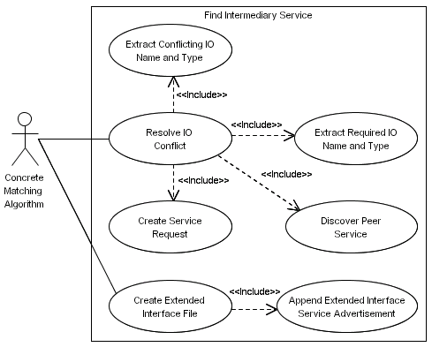
Figure 19 Find Intermediary Service

Issues
The issues associated with the Use Case are not known at this stage.

Requirements
Devices will invoke internal services and/or external services to produce some added value functionality. Within this framework Service Interface are not known a priori. Consequently this brings with it additional challenges and mechanisms need to be developed that can discover and compose services based on the capabilities they provide. Such a mechanism will encounter several problems including different vocabularies and data type conflicts. Devices that receive service requests must try to resolve these conflicts by reformulating service requests and explicitly resolving any data type conflicts that may occur using intermediary services. Devices must determine what parameters are conflicting and attempt to solve these conflicts by discovering services that can perform the required data type conversions. The results received from any intermediary services must be used to replace the conflicting data types – the service can then be executed locally. The number of intermediary services required to solve a particular conflict could be numerous, however we envisage that a pre-determined depth must be implemented in order to avoid network flooding and infinite looping. When an intermediary service is found the device that requested the intermediary service must create an extended interface file and append the intermediary service advertisement to it. This extended interface file itself must be appended to the service interface for the service requesting the intermediary service and returned back to the initial service requester.

Actors/Roles
The actors within this Use Case are as follows:
- Concrete Matching Algorithm: This actor determines if the IOPEs in the service request match the signatures found in the Service Interface. If a signature is found that supports the IOPEs but has data type conflicts this algorithm does not fail but tries to resolve the conflict using intermediary services.

Goals/Context
Within this Use Case there are a number of goals that need to be addressed depending on the particular actor involved.
- Extract conflicting IOPE Name and Data Type from Service Request: If a conflicting IOPE is found it must be extracted from the service request. This IOPE will be used in a new service request, which will specify that a candidate service must take as input the conflicting IOPE data type.
- Extract required IOPE Name and Data Type from Service Signature: When a conflicting IOPE is found the required data type must be extracted from the service interface. This IOPE will be used in the new service request, which specifies that a candidate service must produce the required output data type.
- Create Service Request using the two extracted IOPEs: Using the extracted IOPE data types a new service request must be created.
- Discover Intermediary Service: The new service request must be propagated within the P2P network and the results processed.
- Create Extended Interface file: If an intermediary service is discovered then an extended interface file must be created and the service advertisement for the intermediary service must be appended to it.
- Append Extended Interface file to Service Advertisement: The extended interface file must be appended to the service advertisement to indicate to the initial service requester that it can only accommodate service requests using intermediary services.
- Return Service Advertisement to the initial Service Requester: Once the extended interface file is appended to the service advertisement it must be returned to the initial service requester.

Assumptions
The assumptions are not known at this stage

Scenario/Steps
When a service request has been abstractly matched with a service description and an Atomic Process exists that supports all the IOPEs contained in the service request the Concrete Algorithm checks to see if the data type information for each IOPE in the service request and the signature in the Service Interface conflict. If a conflict is found the Concrete Matching Algorithm begins by extracting the conflicting IOPE from the service request and the required IOPE from the service signature. These two IOPEs are used to create a new service request that states that a candidate service must take as input the conflicting IOPE data type and produce as an output the required IOPE data type. Once this service request is created it is propagated within the P2P network. If a candidate service is found the Concrete Matching Algorithm creates an extended interface file and appends the service advertisement for the intermediary service. At this stage, note that their may be several responses received from the service request. In this instance the capability requirements defined in the service request will be used to determine which candidate services support the required capabilities. All successful intermediary service advertisements will be added to the extended interface file. After the intermediary service advertisement(s) have been added the extended interface file is added to the service advertisement for the service description being processed. The service advertisement is then returned to the initial service requester.

Extensions
No extensions to the details defined above are known at this stage.

Use Case: Encrypt and Decrypt Data

Description
This Use Case illustrates how devices encrypt and decrypt data received from other devices within this framework. The Use Case diagram is illustrated in Figure 20.
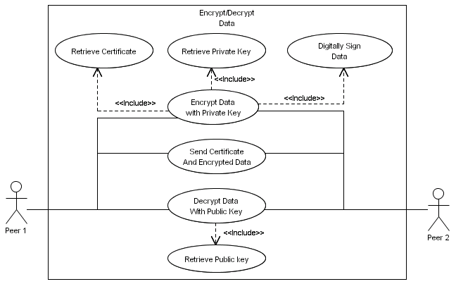
Figure 20 Encrypt and Decrypt Data

Issues
The issues associated with the Use Case are not known at this stage.

Requirements
All data transferred between devices must be encrypted and decrypted. This must be achieved using Public-Key mechanisms and Digital Certificates. When a device sends data it must first encrypt the data using its private key and digitally sign the data using the certificate – the device must first retrieve the private key and the certificate from the devices persistent storage. When the data is encrypted it must be sent to the peer along with the certificate to allow the receiving peer to authenticate the peer sending the data. When data is received it must be decrypted using the peer’s public key. This will require the public key to be retrieved from some persistent storage on the device.

Actors/Roles
The actors within this Use Case are as follows:
- Peer: The peer sends and receives data within the P2P network. As such the peer must ensure that all data sent is encrypted and all data received is decrypted, which includes authenticating the peer that sent the data.

Goals/Context
Within this Use Case there are a number of goals that need to be addressed depending on the particular actor involved.
- Retrieve Private Key: When the peer needs to send data within the P2P network it will first retrieve the Private Key, which is used to encrypt the data.
- Retrieve Certificate: Before the encrypted data is sent it must be digitally signed using the device’s certificate. Before this can be done the peer must retrieve the certificate from the devices persistent storage.
- Encrypt Data: The peer uses the private key and the certificate to encrypt and digitally sign the data.
- Send Encrypted Data and Certificate: Once the data has been encrypted using the private key and digitally signed it is sent to peer(s) in the network along with the certificate. The certificate and the encrypted data are used to authenticate the peer that sent the data.
- Retrieve Public Key: When a peer receives any data from the network it will authenticate the sender of the data and decrypt the data using the required public key. Before this is achieved the public key must be retrieved from the devices persistent storage.
- Decrypt Data: Once the required public key is retrieved it must be used to decrypt the data.

Assumptions
No assumptions for this Use Case are known at this stage.

Scenario/Steps
If a device wishes to send data within the network it first encrypts the data using its private key. The device initially retrieves the private key and the certificate from the devices persistent storage. The private key is used to encrypt the data and the certificate is used to digitally sign the data before it is sent. Once these tasks have been performed the data is propagated along with the certificate within the P2P network. If a peer receives data from within the P2P network it begins by decrypting the data using the relevant public key associated with the peer that encrypted the data. The peer begins by retrieving the public key from the devices persistent storage, which is then used to decrypt the data.

Extensions
No extensions to the details defined above are known at this stage.

References

